Web Scraping and Visualization with Prometheus and Grafana

Configure Prometheus to scrape data from the Blackbox Exporter.

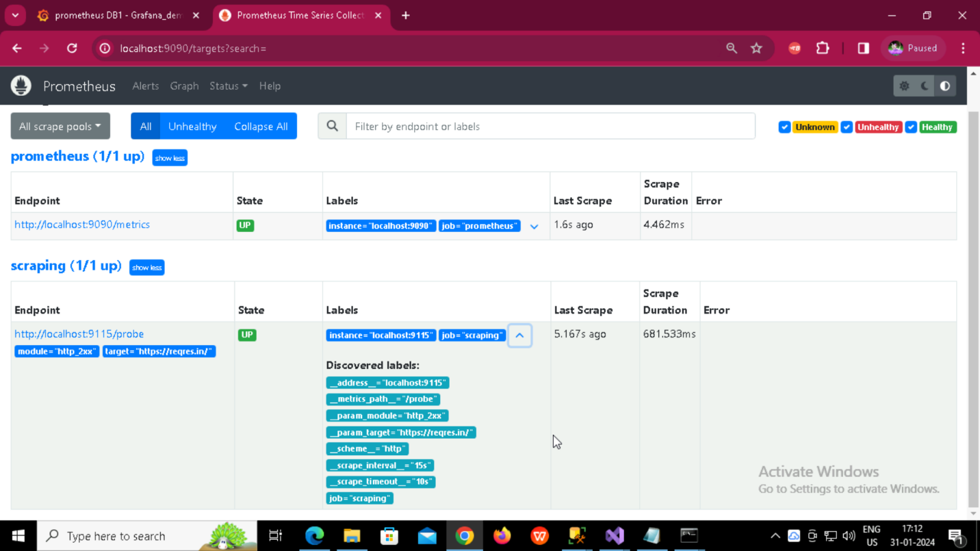

Successfully adding data source in Grafana

Configure Grafana to visualize and manage alerts.

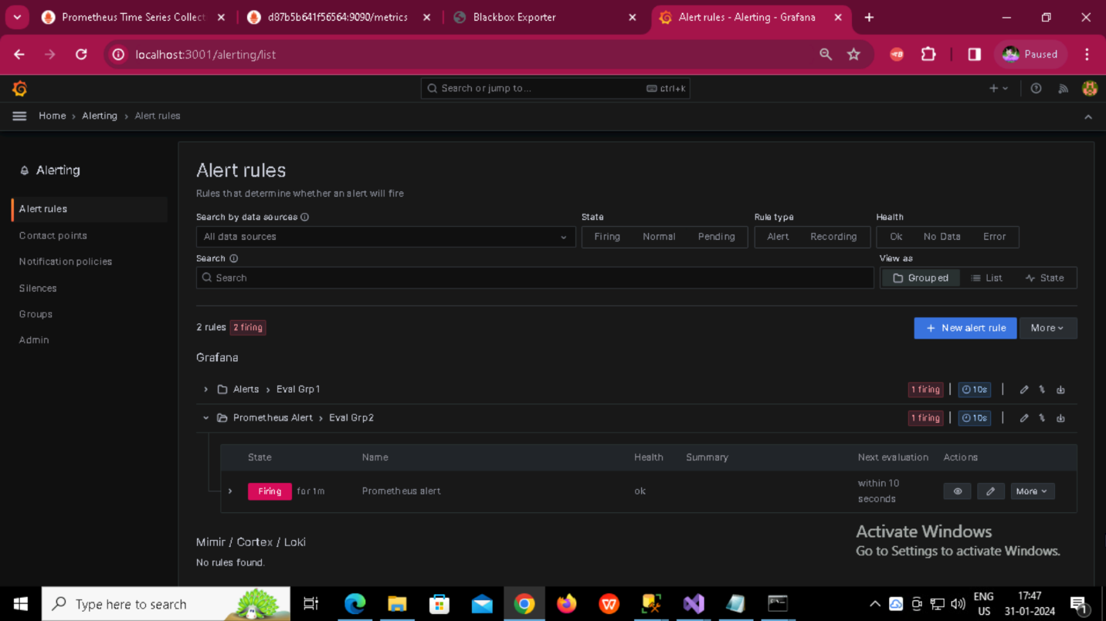

Final Dashboard

